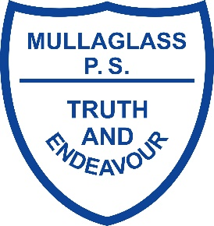
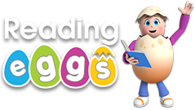

We are excited to offer ‘Reading Eggs’ to all the children at Mullaglass, P1 to P7 on a trial basis from now until the 29th October. All children are encouraged to access the programme daily either through the Reading Eggs app or using a desktop. The Reading Eggs app is not compatible with all tablets and may work better for you through their website - https://readingeggs.co.uk/
It is recommended that children use the Reading Eggs programme for at least 15 minutes daily as evidence shows this can have a positive impact on your child’s reading skills and confidence.
Every child will be given their own login details and an information sheet on how to access the programme from home. There are links on the school website under key information (links for parents) to access Reading Eggs login and an overview of the programme.

Features of Reading Eggs and what it offers
Reading Eggs is designed for 2–13 year olds. The program begins at an absolute beginner level, so children do not need prior knowledge to start. There are three programs within Reading Eggs – Reading Eggs Junior for 2–4 year olds, Reading Eggs for 3–7 year olds and Reading Eggspress for 7–13 year olds.

Reading Eggs makes learning to read interesting and engaging for kids, with great online reading games and activities.

Learn essential reading skills
Children complete animated online lessons where they learn essential reading and phonics skills. The variety of fun activities within each lesson provides the repetition needed for these skills to become part of the child’s long-term memory.

Read books online
Children gain confidence by reading online books that only contain words they have already studied in the programme. There are over 2000 levelled books in the Reading Eggs programme.

Earn rewards
Children earn golden eggs as rewards for the progress they make. They can use these eggs to buy fun reward games and items for their avatar or house. Children also earn a certificate at the end of each map.

